LAB 10:
Question#01:
Code:
#include <iostream>
using namespace std;

template <typename T1, typename T2>
class Calculator
{
T1 num1;
T2 num2;

public:
Calculator(T1 n1, T2 n2)
{
num1 = n1;
num2 = n2;
}

void add()
{
cout << "Addition: " << num1 + num2 << endl;
}

void subtract()
{
cout << "Subtraction: " << num1 - num2 << endl;
}

void multiply()
{
cout << "Multiplication: " << num1 * num2 << endl;
}

void divide()
{
if (num2 != 0)
cout << "Division: " << (double)num1 / num2 << endl;
else
cout << "Division by zero is not allowed!" << endl;
}
};

int main()
{

cout << "=== Int & Int ===" << endl;
Calculator<int, int> c1(10, 3);
c1.add();
c1.subtract();
c1.multiply();
c1.divide();

cout << "\n=== Int & Double ===" << endl;
Calculator<int, double> c2(10, 3.5);
c2.add();
c2.subtract();
c2.multiply();
c2.divide();

return 0;
}

Output:
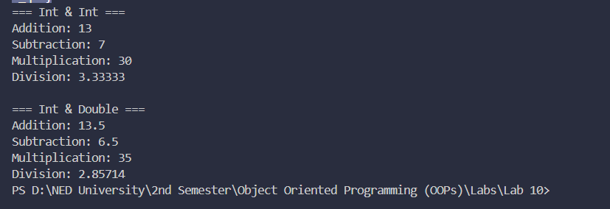

Question#02:
Code:
#include <iostream>
using namespace std;

// Template function for swapping same datatype
template <typename T>
void swapValues(T &a, T &b)
{
T temp = a;
a = b;
b = temp;
}

// Template function for swapping different datatypes
template <typename T1, typename T2>
void swapValues(T1 &a, T2 &b)
{
T1 temp = a;
a = (T1)b;
b = (T2)temp;
}

int main()
{

cout << "=== Int & Int ===" << endl;
int x = 10, y = 20;
cout << "Before Swap: x = " << x << ", y = " << y << endl;
swapValues(x, y);
cout << "After Swap: x = " << x << ", y = " << y << endl;

cout << "\n=== Double & Double ===" << endl;
double a = 3.14, b = 7.77;
cout << "Before Swap: a = " << a << ", b = " << b << endl;
swapValues(a, b);
cout << "After Swap: a = " << a << ", b = " << b << endl;

cout << "\n=== Int & Double ===" << endl;
int p = 5;
double q = 9.99;
cout << "Before Swap: p = " << p << ", q = " << q << endl;
swapValues(p, q);
cout << "After Swap: p = " << p << ", q = " << q << endl;

return 0;
}
Output:
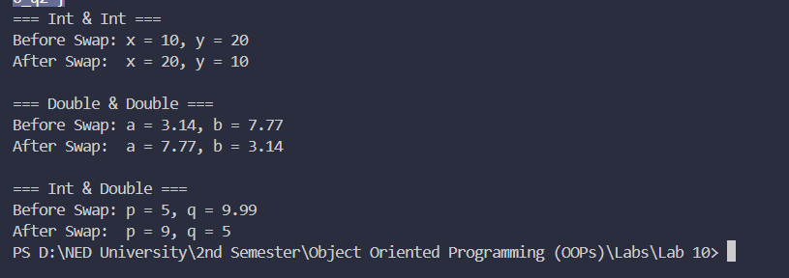

Question#03:
Code:
#include <iostream>
using namespace std;

template <typename T>
class mycontainer {
T element;

public:
mycontainer(T el) {
element = el;
}

void increase() {
element++;
cout << "Increased Value: " << element << endl;
}
};

// Template specialization for char
template <>
class mycontainer<char> {
char element;

public:
mycontainer(char el) {
element = el;
}

void uppercase() {
if (element >= 'a' && element <= 'z')
element = element - 32; // converts to uppercase
cout << "Uppercase: " << element << endl;
}
};

int main() {

cout << "=== Int Container ===" << endl;
mycontainer<int> c1(5);
c1.increase();

cout << "\n=== Double Container ===" << endl;
mycontainer<double> c2(3.14);
c2.increase();

cout << "\n=== Char Container (Specialization) ===" << endl;
mycontainer<char> c3('h');
c3.uppercase();

return 0;
}

Output:
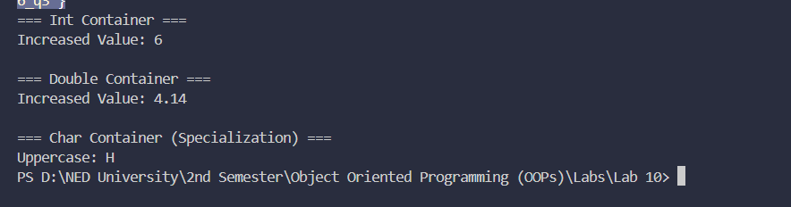

Question#04:
Code:
#include <iostream>
using namespace std;

// Abstract class template for 1D dynamic array
template <typename T>
class AbstractArray {
public:
virtual bool isFull() = 0;
virtual bool isEmpty() = 0;
virtual int size() = 0;
virtual T Front() = 0;
virtual T Rear() = 0;
virtual void enqueue(T val) = 0;
virtual void dequeue() = 0;
virtual void resize() = 0;

virtual ~AbstractArray() {}
};

// Derived Queue class template
template <typename T>
class Queue : public AbstractArray<T> {
T* arr;
int capacity;
int count;
int front;
int rear;

public:
Queue(int cap = 5) {
capacity = cap;
arr = new T[capacity];
count = 0;
front = 0;
rear = -1;
}

bool isFull() override {
return count == capacity;
}

bool isEmpty() override {
return count == 0;
}

int size() override {
return count;
}

T Front() override {
if (isEmpty()) {
cout << "Queue is empty!" << endl;
return T();
}
return arr[front];
}

T Rear() override {
if (isEmpty()) {
cout << "Queue is empty!" << endl;
return T();
}
return arr[rear];
}

void enqueue(T val) override {
if (isFull()) {
cout << "Queue is full! Resizing..." << endl;
resize();
}
rear = (rear + 1) % capacity;
arr[rear] = val;
count++;
cout << val << " enqueued successfully." << endl;
}

void dequeue() override {
if (isEmpty()) {
cout << "Queue is empty! Cannot dequeue." << endl;
return;
}
cout << arr[front] << " dequeued successfully." << endl;
front = (front + 1) % capacity;
count--;
}

void resize() override {
int newCapacity = capacity * 2;
T* newArr = new T[newCapacity];

for (int i = 0; i < count; i++)
newArr[i] = arr[(front + i) % capacity];

delete[] arr;
arr = newArr;
front = 0;
rear = count - 1;
capacity = newCapacity;
cout << "Queue resized to capacity: " << capacity << endl;
}

void display() {
if (isEmpty()) {
cout << "Queue is empty!" << endl;
return;
}
cout << "Queue: ";
for (int i = 0; i < count; i++)
cout << arr[(front + i) % capacity] << " ";
cout << endl;
}

~Queue() {
delete[] arr;
}
};

int main() {
cout << "=== Integer Queue ===" << endl;
Queue<int> q(3); // capacity of 3

q.enqueue(10);
q.enqueue(20);
q.enqueue(30);
q.display();

cout << "Front: " << q.Front() << endl;
cout << "Rear: " << q.Rear() << endl;
cout << "Size: " << q.size() << endl;

// This will trigger resize
q.enqueue(40);
q.display();

q.dequeue();
q.dequeue();
q.display();

cout << "\n=== String Queue ===" << endl;
Queue<string> q2(2);
q2.enqueue("Ali");
q2.enqueue("Sara");
q2.display();
q2.enqueue("Ahmed"); // triggers resize
q2.display();

return 0;
}

Output:
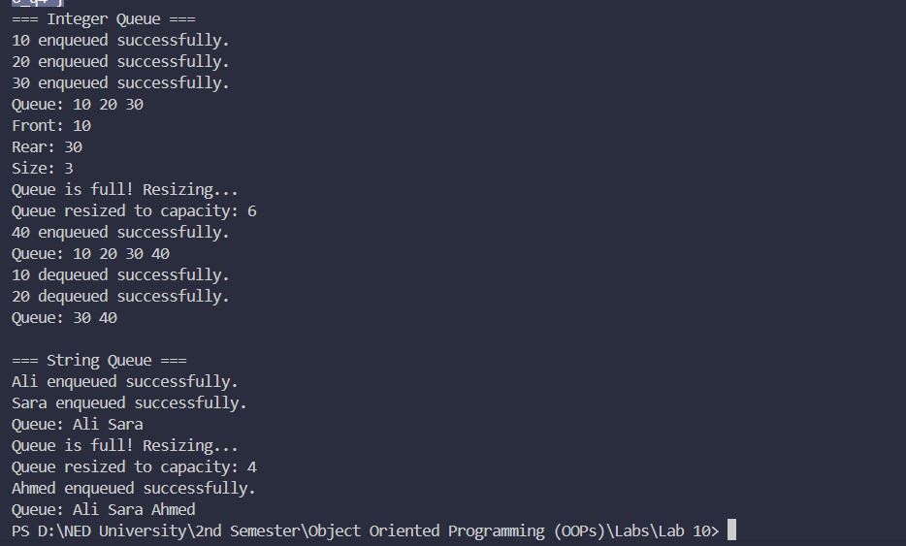

Question#05:
Code:
#include <iostream>
#include <string>
using namespace std;

template <typename T>
class AbstractArray
{
public:
virtual bool isFull() = 0;
virtual bool isEmpty() = 0;
virtual int size() = 0;
virtual T Front() = 0;
virtual T Rear() = 0;
virtual void enqueue(T val) = 0;
virtual void dequeue() = 0;
virtual void resize() = 0;
virtual ~AbstractArray() {}
};

template <typename T>
class Queue : public AbstractArray<T>
{
T *arr;
int capacity;
int count;
int front;
int rear;

public:
Queue(int cap = 5)
{
capacity = cap;
arr = new T[capacity];
count = 0;
front = 0;
rear = -1;
}

bool isFull() override { return count == capacity; }
bool isEmpty() override { return count == 0; }
int size() override { return count; }

T Front() override
{
if (isEmpty())
{
cout << "Queue is empty!" << endl;
return T();
}
return arr[front];
}

T Rear() override
{
if (isEmpty())
{
cout << "Queue is empty!" << endl;
return T();
}
return arr[rear];
}

void enqueue(T val) override
{
if (isFull())
resize();
rear = (rear + 1) % capacity;
arr[rear] = val;
count++;
}

void dequeue() override
{
if (isEmpty())
{
cout << "Queue is empty!" << endl;
return;
}
front = (front + 1) % capacity;
count--;
}

void resize() override
{
int newCapacity = capacity * 2;
T *newArr = new T[newCapacity];
for (int i = 0; i < count; i++)
newArr[i] = arr[(front + i) % capacity];
delete[] arr;
arr = newArr;
front = 0;
rear = count - 1;
capacity = newCapacity;
}

~Queue() { delete[] arr; }
};

// ---- Print Shop Class ----
class PrintShop
{
Queue<string> jobQueue;
bool printerIdle;

public:
PrintShop() : jobQueue(5)
{
printerIdle = true;
}

// Add a print job to the queue
void addJob(string job)
{
cout << "Job received: \"" << job << "\" added to queue." << endl;
jobQueue.enqueue(job);

// If printer is idle, start printing immediately
if (printerIdle)
processJob();
}

// Process the next job in queue
void processJob()
{
if (!jobQueue.isEmpty())
{
printerIdle = false;
string job = jobQueue.Front();
jobQueue.dequeue();
cout << "Printing: \"" << job << "\"..." << endl;
cout << "\"" << job << "\" completed!" << endl;

// Check if more jobs exist
if (!jobQueue.isEmpty())
{
cout << "Next job found in queue. Continuing..." << endl;
processJob(); // process next job
}
else
{
printerIdle = true;
cout << "No more jobs. Printer is now idle." << endl;
}
}
}
};

int main()
{
PrintShop shop;

cout << "===== Print Shop Simulation =====" << endl
<< endl;

shop.addJob("Resume.pdf");
cout << endl;
shop.addJob("Assignment.docx");
cout << endl;
shop.addJob("Invoice.pdf");
cout << endl;
shop.addJob("Report.docx");

return 0;
}

Output:
